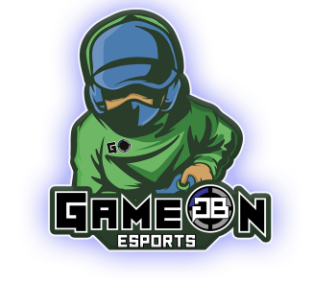
GameOn Gaming Center’s Spring League 20201
Objective
Our objective as GameOn is to inform the youth about healthy gaming habits, connect with other Gamers, and achieve new heights in the competitive scene as a player.
Outline
- Games being Offered: Fortnite, Valorant, Rocket League and League of legends
- Child cannot participate in both Rocket League and Valorant, due to conflicting tournament times.
- 9-week season April 12th-June 12th
- In Person or Virtual
- Children ages 10-17 are eligible to participate
- No extra cost to participate in multiple Video Games
- 2x practices per week; one hour and a half each
- 1x Zoom Life coach session Weekly, 9x Total
- 8 Tournament dates + National Championship (based on performance)
- One player card for social media use by gamer
- One “GameOn” Jersey
- $185 For new players, $165 for Returning Players
Practice Times
Monday………………….**Zoom TeamChat** (5:30-6:00p EST), Fortnite (6-7:30pm EST), Valorant (7:30-9pm EST)
Tuesday………………………………………………………Rocket League (6-7:30pm EST), League of Legends (7:30-9pm EST)
Wednesday…………………………………………………………………………. Fortnite (6-7:30pm EST), Valorant (7:30-9pm EST)
Thursday…………………………………………………….Rocket League (6-7:30pm EST), League of Legends (7:30-9pm EST)
Friday…………………………………………………………………………….…………………………………………………………………………. N/A
Saturday: Tournament
Fortnite Matches at 12:30 - 3:00 PM (EST)
Rocket League Matches at 3:30 - 5:30 PM (EST)
Valorant Matches at 3:30 - 5:30 PM (EST)
Sunday: Sunday: Tournament
League of Legends Matches at 2:30 - 5:30pm (EST)
**Zoom Life Coaching Team Chats** on Mondays from 5:30pm-6:00p (EST) Via Zoom
To Register your child, Please Call (757)-575-1033
Spring Schedule
Week Date Zoom Topic Meeting Opportunity
Week One | April 11th- 17th | Introduction/  The history of Gaming | N/A
Week Two | April 18th- 24th | How to Approach  Cyber Bullying/  Internet Safety | N/A
Week Three | April 25th- May 1st | Internet Safety Cont. | ODU Zoom Call  Saturday May 1st @6pm With Grant Deppen
Week Four | May 2nd- May 8th | Basics of Nutrition/Hygiene | Open Play  Saturday, May 1st  6pm-9pm  @GameOn
Week Five | May 9th - May 15th | Physical Health/Gaming Posture | Regent Zoom Call Saturday, May 15th @6pm with Nathan Tillet
Week Six | May 16th - May 22nd | Team Communication | Mafia Game in Discord  Saturday May 22nd @ 6pm
Week Seven | May 23rd - May 29th | Becoming a Content Creator | Bryant and Straton Zoom Call @6pm  Saturday May 29th?
Week Eight | May 30th - June 5th | Shout Casting | Open Play  Saturday, June 5th  6pm-9pm  @GameOn
Week Nine | June 6th - June 12th | Gyo Score/ Scholarship Opportunities | “Defy trampoline park” group jump with Parents permission  Saturday, June 12th, 8pm-10pm
Award Ceremony June 19th at 3pm at GameOn Gaming Center/Virtually on Zoom.

